Experiment:2
MATLAB Simulation of Cellular Coverage, Cell Splitting and Handoff in a Multi-Cell Network
OBJECTIVES:
By the end of the experiment, students should be able to: 1. Model adjacent hexagonal cell coverage and identify cell centers and boundaries. 2. Estimate the number of cells required to cover a fixed service area for different cell radii. 3. Compare estimated users served under an explicit per-cell capacity assumption. 4. Simulate a mobile moving across a cell boundary and identify the serving-cell transition.
PROGRAME CODE:
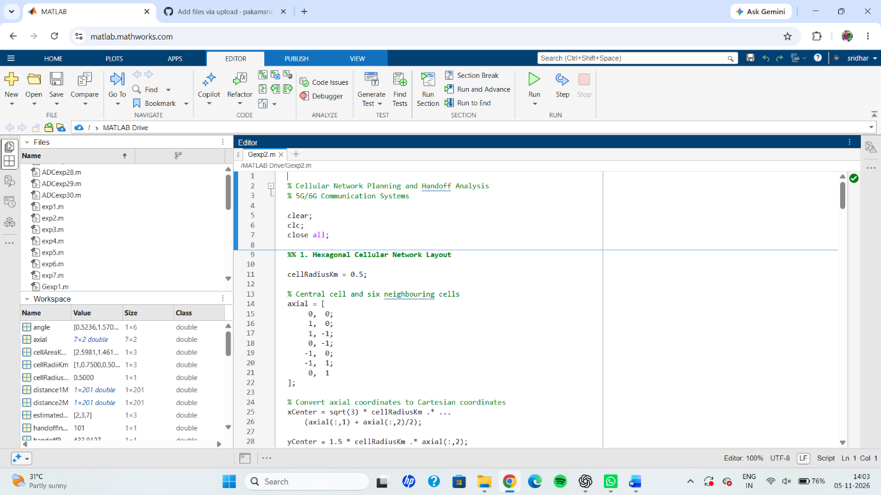
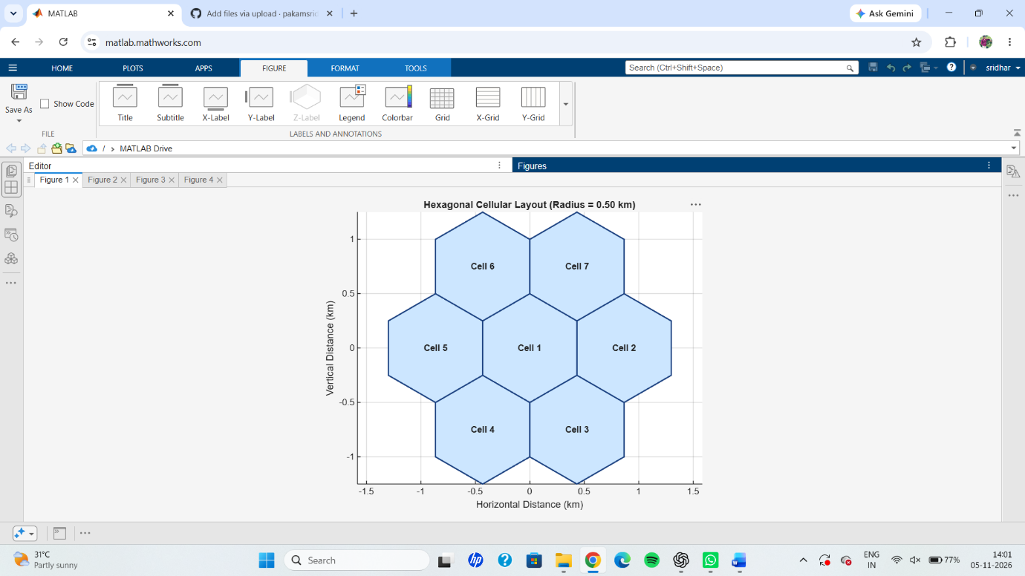
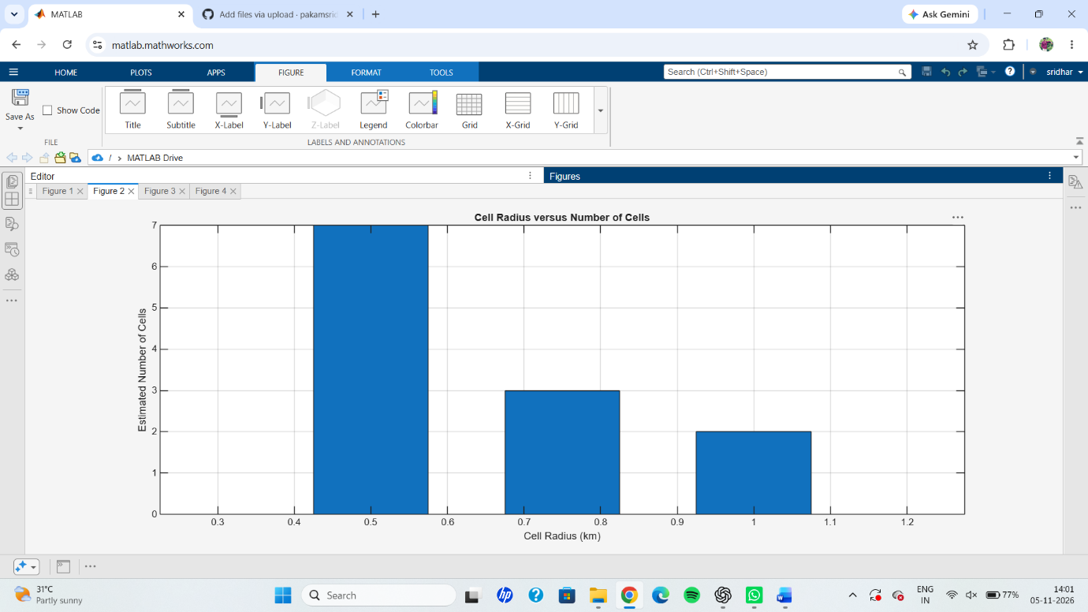
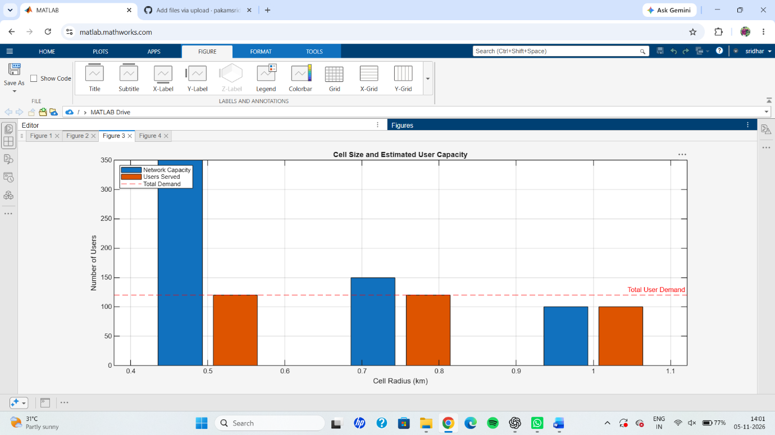
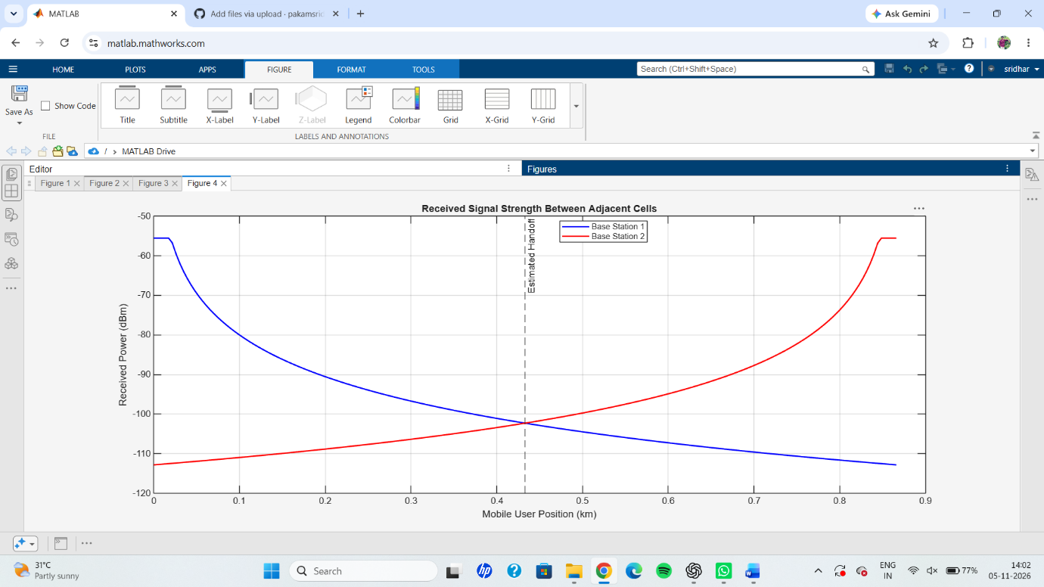
RESULT: The cellular network planning and handoff analysis were successfully simulated using MATLAB. A hexagonal cellular layout consisting of one central cell and six neighbouring cells was generated. The simulation showed that decreasing the cell radius increases the number of cells required and the overall network capacity. For the selected study area of 4 km², the estimated network capacities were 100, 150 and 350 users for cell radii of 1.0 km, 0.75 km and 0.5 km, respectively. The handoff analysis identified an approximate handoff position of 433 m from Base Station 1. Thus, the experiment demonstrated cellular coverage planning, user capacity estimation and handoff between adjacent base stations.

